**Setup Document of Angular 4**

Step#1: Get Node.js from Appstore.

Step#2: Open Node.js command prompt: 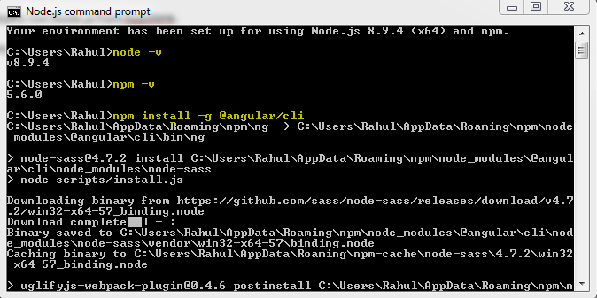

Step#3: Type ng – v to check if Angular CLI has been installed successfully or not..

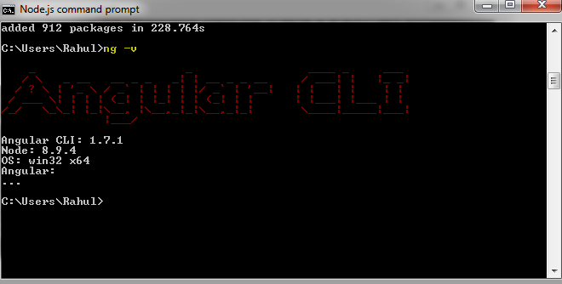

Step#4: Create a Angular4 project:

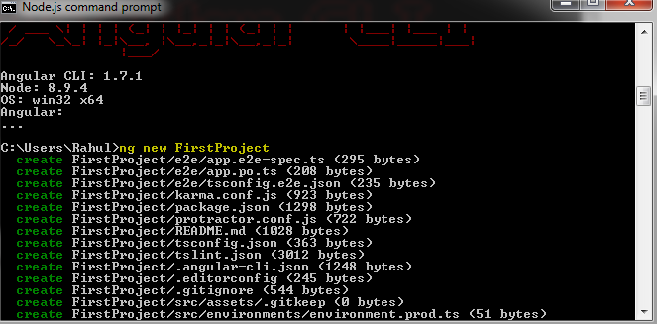

Step#5 To run the server and launch the basic application:

